**ASSIGNMENT**

**(HTML 5)**

# 1) What are the new tags added in HTML 5?

Ans: The new tags added in HTML 5 are <article>, <aside>, <audio>, <canvas>, <datalist>, <details>, <footer>, <header>, <mark>, <section>, <video>.

# 2) How to embed audio and video in a webpage?

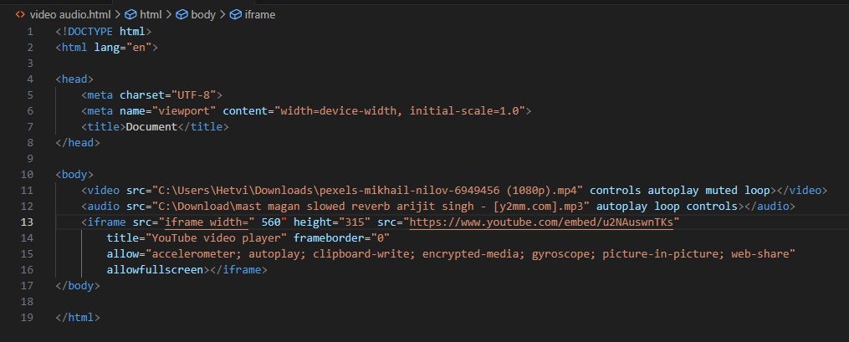



# 3) Semantic Elements in HTML 5?

Ans: A semantic elements clearly describes its meaning to both the browser and the developer.

Examples of semantic elements are:- <form>, <table> and <article> because it clearly defines its content.

# 4) Canvas and SVG tags?

Ans: SVG (Scalable Vector Graphics) is an XML-based vector image format, suitable for creating graphics and interactive elements. Canvas is more like a blank canvas where you want whatever you draw using pixels.

